Professional Development For 2015
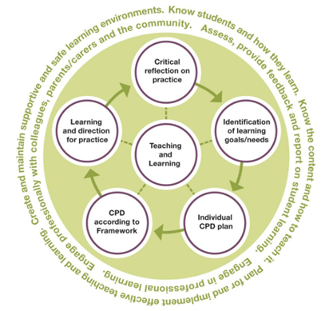

To maintain annual registration in Queensland, most teachers aim to undertake and record a minimum of 20 hours professional development that meets the AITSL standards. This professional development needs to demonstrate:
- a balance across the following identified areas
- employer directed and supported CPD
- school supported CPD
http://www.qct.edu.au/PDF/PSU/CPDFrameworkPolicy_AmendedforAustralianStandards.pdf

- teacher identified CPD; and
- a range of types of CPD activities.

Holiday PD Offerings

Got data, Now What
Presented by: Christine Masters
9:00pm – 3:00pm
C1, CES – April 8

Best practice would dictate that we cannot improve students’ educational needs if we do not know what their needs are. Teachers are collecting a range of achievement data but what can we do with it?

A characteristic of good data is its potential to help teachers make good decisions about children’s learning. Data tells a story . . .
What story is the data is telling me?

Creating Task and Criteria Sheets
Presented by: Maree Dinan-Thompson
9:00pm – 3:00pm
C1, CES – April 10

Teachers will explore assessment tasks - writing task descriptions and criteria for judgment for both teachers and students (kid speak). Teachers will be required to bring along a task to revise during the workshop.

Are Running Records Really a Useful Tool?
Presented by: Christine Masters
9:00pm – 3:00pm
C1, CES – July 8

So you have completed running records for your students. Now what? Are they completed to satisfy the record keeping policy or can you really use the information gathered to inform the learning opportunities you provide your students? Teachers will explore the variety of information that can be obtained from a running record and how to use this to provide differentiated learning opportunities to meet the needs of all students.

Tactical Teaching Thinking
Presented by: Christine Masters
9:00pm – 3:00pm
C1, CES – September 23

The Diocesan Learning Framework has at its heart the development of learners who are Inquiring & Reflective. The Australian Curriculum also recognises the importance of thinking skills and has incorporated this in the Critical and Creative Thinking General Capability. How are you assisting your students in this area? This workshop will provide you with a range of powerful teaching activities, for both critical and creative thinking, that can be utilised in your classroom.

Register through the Professional Development Calendar on the Staff Portal or contact Mandy at ashephard@cns.catholic.edu.au

