**Professional Development For 2015**

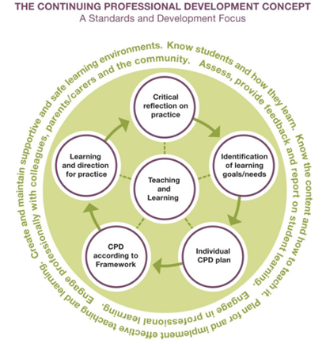

**To maintain annual registration in Queensland, most teachers aim to undertake and record a minimum of 20 hours professional development that meets the AITSL standards. This professional development needs to demonstrate:**

* **a balance across the following identified areas**
* **employer directed and supported CPD**
* **school supported CPD**

<http://www.qct.edu.au/PDF/PSU/CPDFrameworkPolicy_AmendedforAustralianStandards.pdf>

* **teacher identified CPD; and**
* **a range of types of CPD activities.**

**Regional PD Offerings**

**Term One**

**Term Three**

**Exploring the building blocks of language – Grammar & Punctuation**

**Presented by: Carly Steele and Michelle King**

**4:00pm – 5:30pm**

**Innisfail – March 17**

**Atherton – March 18**

**C1, CES – March 19**

*“Knowledge about grammar is only useful if students use it to read and write, and recognise how authors, including themselves, can use language to make meaning”* (Rossbridge & Rushton).

Using texts, teachers will explore how to move students beyond the “So what?” stage of naming parts of speech and punctuation.

**Term Two**

**Simply Spelling**

**Presented by: Carly Steele and Michelle King**

**4:00pm – 5:30pm**

**Innisfail – May 5**

**Atherton – May 6**

**C1, CES – May 7**

Teachers will explore various teaching strategies across all areas of spelling that can be implemented in the classroom, alongside student activities designed to consolidate spelling knowledge.

**Problem Solving – Teaching to the Core of Maths**

**Presented by: TBA**

**4:00pm – 5:30pm**

**Innisfail – June 16**

**Atherton – June 17**

**C1, CES – June 18**

Teachers will explore how to approach a problem, and to recognise the kinds of thinking they need to do before finding a solution. The aim is to increase learner’s self-awareness and ability to draw on an increasing number of strategies for enhancing learning and independent problem solving.

**Writing**

**Presented by: Carly Steele and Michelle King**

**4:00pm – 5:30pm**

**Innisfail – August 4**

**Atherton – August 5**

**C1, CES – August 6**

Teachers will explore how to plan for, and deliver, an effective writing programme that both promotes engagement and equips students with the tools they need to meaningfully engage with the writing process.

**Still Googling?**

**Presented by: TBA**

**4:00pm – 5:30pm**

**Innisfail – Sept 15**

**Atherton – Sept 16**

**C1, CES – Sept 17**

Teachers will:

* develop further skills in using Google Apps For Education (GAFE)
* develop an understanding of the integration of GAFE and Teacher Dashboard

**Term Four**

**Reading**

**Presented by: Carly Steele and Michelle King**

**C:\Users\csteele\AppData\Local\Microsoft\Windows\Temporary Internet Files\Content.IE5\A0OYZK28\MC900232441[1].wmf4:00pm – 5:30pm**

**Innisfail – October 20**

**Atherton – October 21**

**C1, CES – October 22**

Teachers will explore the processes involved with reading that encourage a strategic approach to teaching. Teaching reading through whole-class instruction and guided reading will be closely examined.



**Register through the Professional Development Calendar on the Staff Portal or contact Mandy at ashephard@cns.catholic.edu.au**