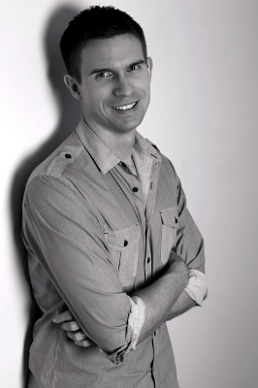

**Full Day:**

Non-Member (Teacher) $50

MTAQ Member (Teacher) $40

Student $20

**Per Session:**

Non-Member (Teacher) $20

MTAQ Member (Teacher) $15

Student $8



Cairns Choral Society Hall, Greenslopes Street, Cairns

For all enquiries – please phone Anne Linneman 4056 2055

# Venue

9:30am Registration

10:00-11:15am ***Composing***

11:15-11:45am Morning Tea

11:45-1:00pm “***Contemporary” Music***

1:00-1:45pm Lunch

1:45-3:00pm ***My Pieces***

***\*Morning tea provided, Lunch BYO***

# Schedule Cost

***Composing***

* How I do it
* Tools, tips and tricks for students (and teachers) looking to compose

***“Contemporary” Music***

* What is it? What does it sound like?
* What styles do students today engage with?

***My Pieces***

* How it all began – the story behind *Supersonics*
* *Supersonics Book One* and *Soundscapes Book One* – linking contemporary sounds with the development of a strong classical technique
* *Supersonics Book Two and Book Three*, *Soundscapes Book Two* and *Soundwaves* – stories behind the pieces, performance tips, teaching tips, etc.

Australian composer, Daniel MacFarlane

Music Teachers’ Association of Queensland Inc.

Cairns and District Branch

CONTEMPORARY PIANO WORKSHOP

22 April 2012

# Biography

Daniel MacFarlane was born in Melbourne, Australia in 1979. After moving to Brisbane, he commenced music lessons at age four. He studied initially under Mark Gibson and later went on to further study at the University of Queensland under Bevan Crabtree. For the last fifteen years Daniel has taught students piano, theory and composition in Brisbane. His first series of compositions, *Supersonics*, was released in 2008. This was followed by the release of *Soundwaves* and *Soundscapes* in 2011. Daniel’s compositions are listed on the St. Cecilia, ANZCA and Australian College of Music piano syllabi. He is also an examiner for the St. Cecilia examining board. In addition to his musical activities Daniel has excelled on the sporting field, representing Australia in athletics.

Name: _____________________________________________________

Email Address: ______________________________________________

Ph. Number: ________________________________________________

MTAQ Membership No. ______________________________________

**Full Day:**

Non-Member (Teacher) $50 _____

MTAQ Member (Teacher) $40 _____

Student $20 _____

Please make cheque payable to MTAQ Inc. Cairns and District Branch and post

with registration form to: P.O. Box 144W Westcourt 4870

Alternatively you may pay by direct deposit:

BSB 064825

Account No. 00900554

Ref. ‘participant’s name’

and email registration details to robynb@ledanet.com.au

**Per Session:**

Non-Member (Teacher) $20 _____

MTAQ Member (Teacher) $15 _____

Student $8 _____

# Please register by 17 April 2012

Registration Form