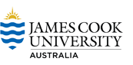
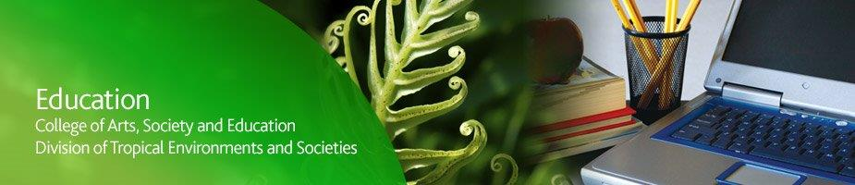

JCU Maths Update Seminar - Cairns

Dear
James Cook University invites school leaders, mathematics teachers, guidance officers and community members to a seminar on the mathematics transition to university of primary and secondary preservice teachers and other first year maths students.

The seminar will also seek feedback on proposed federally funded projects to improve engagement with mathematics in Far North Queensland.

The proposed program will be presented by JCU mathematics educator Dr Jo Balatti, mathematician Dr Shaun Belward and QAMT Cairns Branch President Anja van Hooydonk.

Main topics are:
- Building the maths teaching capacity of future generations of primary and secondary mathematics teachers – progress made on the Inspiring Mathematics and Science in Teacher Education (IMSITE) project
- Data on transition from high school to 1st Year Mathematics – what you need to know
- Launching the Queensland STEM Education Network (QSEN) in Far North Queensland
- Feedback from school-based professionals on proposed community initiatives to enhance student engagement in mathematics

Teachers attending will receive certificates of participation specific to appropriate AITSL Professional Standard 7.4 Engage with professional teaching networks and broader communities.
Date: Thursday, 7th May, 2015
Time: Afternoon Tea at 4:00pm, start 4:15pm, conclude 6pm
Location: The Library, St Mary’s Catholic College
53 Anderson Road, Woree, Cairns (Map)
Parking: At either the primary or secondary school car parks

REGISTRATION
For catering purposes please register by Wednesday, 29th April 2015 by clicking on the link below and filling out the details:
Click here to register

For further information please contact:
Dr Donna Rigano, Project Manager
Inspiring Mathematics & Science in Teacher Education (IMSITE)
P (07) 47814634
E donna.rigano@jcu.edu.au

