***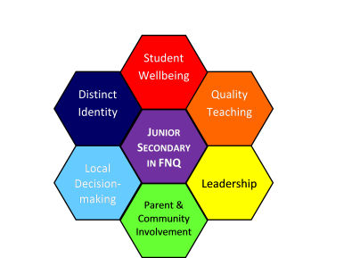* Professional Development Opportunity**

***Teaching Adolescents***

**Presenter: Dr Michael Nagel**

**Date: 21st October, 2013 (pupil free day)**

**Time: 9:00am – 3:00pm (8.30am for registration)**

**Venue: Edge Hill SS Performing Arts Complex**

**Cost: $95 (includes morning tea & lunch)**

Dr Michael Nagel is currently an Associate Professor in the School of Science and Education at the University of the Sunshine Coast where he teaches and researches the areas of human development, behaviour, cognition and learning.

**Topics for the Cairns session include:**

* Understanding adolescent neurological development to implement the most effective pedagogical practices in Junior Secondary
* Building and maintaining teacher-student relationships
* Repairing negative or damaged teacher-student relationships
* Motivating adolescents
* Considerations for your school’s Junior Secondary model

[**Register here**](http://www.learningplace.com.au/events/showitem.asp?eid=14805) ** Registrations close: 16th October 2013**

**For further information contact the FNQ Junior Secondary Education Advisors.**

[Vicki.Hartley@dete.qld.gov.au](mailto:Vicki.Hartley@dete.qld.gov.au) Ph. 40465 268 [Mark.Holland@dete.qld.gov.au](mailto:Mark.Holland@dete.qld.gov.au) Ph. 40465 264

***Send 4 staff for the cost***

***of only 1 TRS day!***