T’BAY WRITERS FESTIVAL
Cairns Writer’s Festival 2013
Trinity Bay State High School
24th and 25th July 2013

Trinity Bay State High School would like to invite students from Year 6 to Year 12 to attend our annual Writer’s Festival. This is a “do not miss” opportunity for students of Far North Queensland to meet and be mentored by some of the world’s most famous authors and illustrators.
The event will be held in our school library from 9am to 3pm on Wednesday 24th and Thursday 25th July, 2013. The cost to attend both days is only $25 per child. Most schools will organise group bookings and students will need to pay by cash or card directly to their school office. When making your payment it is important that you please give the details from the form below. Please also note that we do not “hold seats” without payment. Our festival is very popular and we only have 100 seats available. First in to pay (with student names) is “first served” so to speak. Bookings open as of Monday 3rd June, 2013.
If schools send more than 5 students to our event, they need to be accompanied by an adult (free entry). The adult may be a responsible parent designated by the school. Also, note that lunch is not provided for students. They will need to bring a packed lunch or money for the canteen. Students also need to wear school uniform to our event.
Please see overleaf for details about this year’s guest speakers. We are very excited! For further information, please do not hesitate to contact: Ms Dagmar White (40375246) or Ms Shannon Logan (40375232). We are both available on 40 375 222, or contact Dagmar White via email on dwhit77@eq.edu.au.

--------------------------------please cut along dotted line and return with payment ----------------------------

STUDENT NAME: _______________________________________ YEAR LEVEL: __________
SCHOOL: ____________________________________________________________________
Schools sending individual or groups of students must email through a list to our teacher librarian Dagmar White: dwhit77@eq.edu.au at time of payment. Each school will have a person responsible for registering students for this festival and will know the best way to do this when you make your payment.

I give permission for my student to attend THE T’BAY WRITERS FESTIVAL on July 24 and 25, 2013.
Parent’s Signature: ____________________________________
T’BAY WRITERS FESTIVAL
Guest Speakers
__________________________________________________________________________________________

BOORI (MONTY) PRYOR
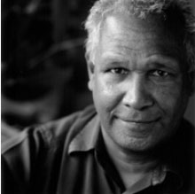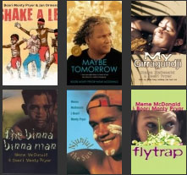
A multi-talented author/performer and articulate public speaker. His presentations engage his audience to participate and are not only enlightening but very entertaining. He has collaborated with Meme McDonald on five books: `Maybe Tomorrow’ (received a special commendation 1998 Human Rights Awards), `My Girragundi’ (won The Children’s Book Council of Australia Award in 1999), Monty is The Children’s Laureate of Australia for his picture book `Shake a Leg’, sharing this title with Alison Lester in 2012 and 2013.

JOHN HEFFERNAN
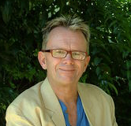
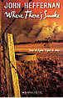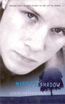
“I write for older readers and younger readers, on a range of subjects, with a range of styles and genre. Picture books, chapter books, YA novels, reality to fantasy, I like to dabble in them all.”
Notable Book Award, Children's Book Council of Australia, for Spud; Environmental Award for Children's Literature shortlist, Wilderness Society, for Rachael's Forest; Australian Children's Book of the Year for younger readers, 2002, for My Dog; Australian Children's Book of the Year shortlist for picture book, and Crichton Award shortlist, both 2004, both for Two Summers.

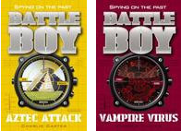

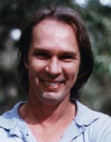
PRUE MASON KIM GAMBLE
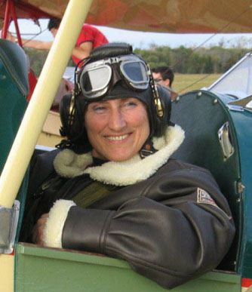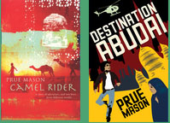
One of Australia’s most popular illustrators; well known for his Tashi series and his Minton books, created in collaboration with author Anna Fienberg. `The Hottest Boy Who Ever Lived, Joseph’ was shortlisted for the CBCA 2002 Picture Book of the Year Award.
Kim Gamble is widely known and loved for his engaging talks where his 'hands-on' approach, creating magnificent pictures with pastels as he goes, has inspired numerous students and teachers. Delightful drawing workshops, that
inspire and entertain.

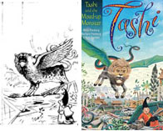
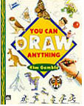
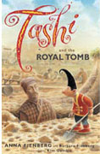
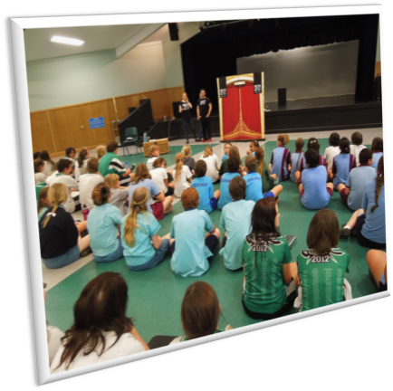
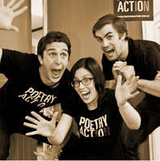
Having travelled and lived in the Middle East, Prue Mason likes to write about cultural diversity and cultural understanding. Her workshops are highly interactive and exciting, anything from developing a scary story to creating believable characters.
Camel Rider won the Premier’s Literary Award for Best Children’s Book 2005.
POETRY IN ACTION
Poems are performed as comic scenes, dramatic monologues, character studies, classical recitations and contemporary interpretations, making poetry accessible and easier to study.

